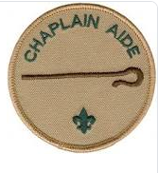
Responsibilities
Provide a spiritual element for campouts and troop meetings
Provide spiritual counseling when needed or requested
Provide opportunities for all boys to grow in their relationship with God and their fellow Scouts
Encourage Scouts to participate in the religious emblems program of their respective faith
Be familiar with the chaplain aide section of this manual
Work with the troop chaplain aide to plan and conduct an annual Scout-oriented religious observance, preferably during Scout Week in February

