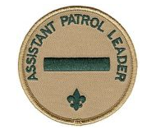
Responsibilities
- Helps the patrol leader plan and steer patrol meetings and activities
- Helps him keep patrol members informed
- Helps the patrol get ready for all troop activities
- Represents his patrol at patrol leader’s council meetings when the patrol leader cannot attend
- Lends a hand controlling the patrol and building patrol spirit
- Sets a good example
- Wears the uniform correctly
- Lives by the Scout Oath and Law
- Shows Scout spirit

