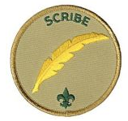
Responsibilities
- attends and keeps a log of patrol leaders’ council meetings
- records individual Scout attendance and dues payments
- records individual Scout advancement progress
- works with the troop committee member responsible for records and finance
- sets a good example
- wears the Scout uniform correctly
- lives by the Scout Oath and Law
- shows Scout spirit

