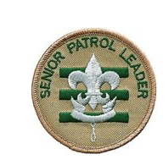
- runs all troop meetings, events, activities, and the annual program planning conference
- runs the patrol leaders’ council (PLC) meetings
- appoints other troop junior leaders with the advice and counsel of the Scoutmaster
- assigns duties and responsibilities to junior leaders
- assists the Scoutmaster with junior leader training
- sets a good example
- wears the Scout uniform correctly
- lives by the Scout Oath and Law
- shows Scout spirit

